Algorithm Modelling Tools : Flowchart , Pseudo-code, Trace Table

 | Structured English | Pseudocode | Flowchart
Sequence and Assignment | SET A TO 100  INCREMENT A BY 1 | DECLARE A: INTEGER  A <- 100  A <- A + 1 | 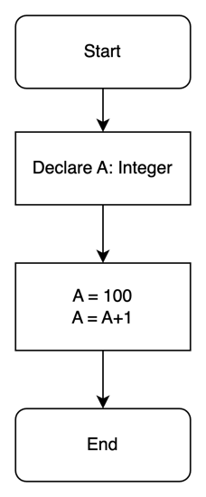
Input | GET INPUT B FOR TEMPERATURE IN CELCIUS | OUTPUT "Enter Temp. in Cels"  INPUT B | 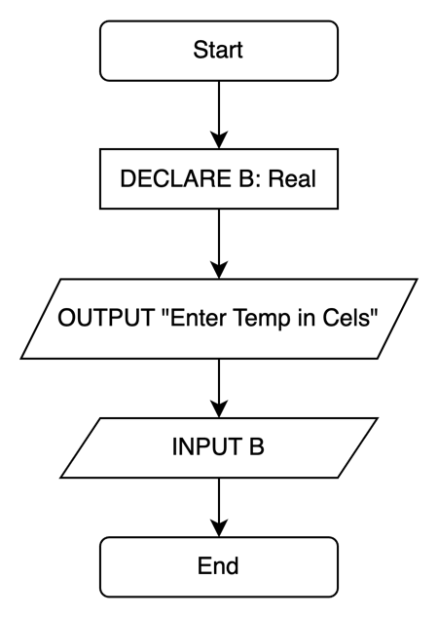
Output | OUTPUT "TEMPERATURE IN CELSIUS IS ", B | OUTPUT "Temp in Cels =", B

Selection | IF A IS GREATER THAN B THEN  SET C TO FUNCTION Factorial(A)  ELSE IF  SET C TO FUNCTION SqRoot(B)  ELSE  SET C TO FUNCTION SqRoot(A) | DECLARE A, B, C : INTEGER  INPUT A, B  IF A > B THEN  C <- factorial(A)  ELSE IF A = B THEN  C <- SqRoot(B)  ELSE  C <- SqRoot(A)  ENDIF | 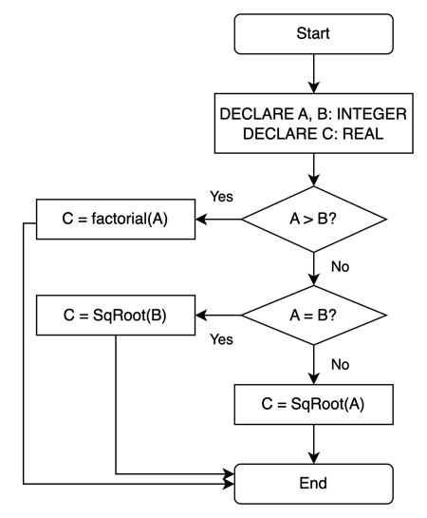
Iteration | WHILE A IS GREATER THAN B INCREMENT B by 1 | WHILE A > B  B <- B + 1  ENDWHILE | 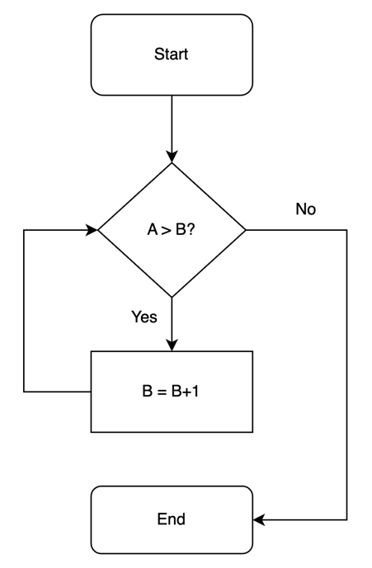
Iteration | FOR I = 1 TO 10 OUTPUT I*I | // I is assigned from 1 to 10 inclusive  // increment can be negative  FOR I <- 1 TO 10 STEP 1  OUTPUT I*I  NEXT I | 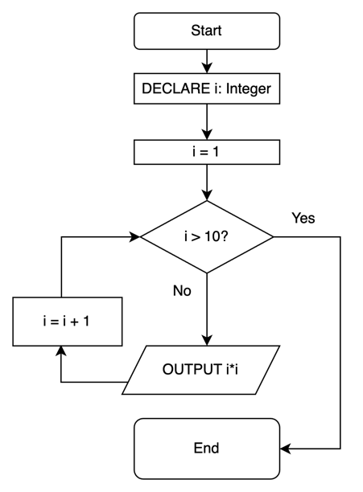

Datatypes in pseudocode: INTEGER, REAL, CHAR, STRING, BOOLEAN, DATE
FLOWCHART RULES:
- Except for the DECISION SYMBOL, Only 1 arrow in and 1 arrow out
- DECISION SYMBOL has 1 arrow in and 2 arrows out (Y and N)
- LINES cannot cross each other
- START terminator may be a FUNCTION declaration
- END terminator may be a RETURN
- SYNTAX follows Pseudo code conventions
SYMBOLS
TERMINATOR (START, END, FunctionName, RETURN)
PROCESS (DECLARE, ASSIGN, Calculate)
INPUT,OUTPUT
DECISION

Pseudo-code Notes:
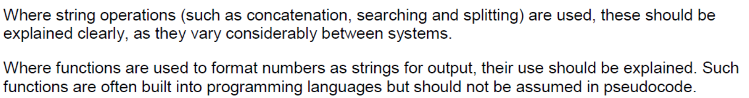
Declaring variables | DECLARE MyScore : INTEGER
Declaring a 1-D array | DECLARE Marks: ARRAY[0:9] OF INTEGER  DECLARE Names: ARRAY[0:9] OF STRING  //Array is fixed size: Array[start: end]  //Array[0], Array[1], …, Array[9]  //Array can only store same data type
Declaring a 2-D array | DECLARE Marks: ARRAY[0:9] OF (ARRAY[0:3] OF STRING)  Array[5][1] <- “first”
Using an Abstract Data Type like List, Dictionary | DECLARE Marks : LIST  DECLARE Scores : DICTIONARY  Marks.APPEND(10) // append method add 10 to end of Marks  Submarks <- Marks.SUBLIST(2,4) // assigns  Scores["John"] = 58 // Store a dictionary object with a key "John"

Declaring a function/method | FUNCTION Factorial(n : INTEGER) RETURNS INTEGER  DECLARE Result : INTEGER  Result ← 1  FOR i ← 1 TO n  Result ← Result * i  ENDFOR  RETURN Result  ENDFUNCTION
Procedure | //Block of code that doesn’t return anything

Practice:

- Write the pseudocode and create a flowchart to model the following Python code:

a = 1
while a % 7 != 0:
if a % 2 == 0:
print("O" , end = "")
if a == 2:
print("X" , end = "")
a = a + 1
print("")

# a%7 in pseudocode: “a MOD 7”  # a//7 in pseudocode: “a DIV 7” or “INT(a/7)”  # != in pseudocode: “<>”  DECLARE a: INTEGER  a ← 1  WHILE a MOD 7 <> 0  IF a MOD 2 = 0 THEN  OUTPUT “O”  ENDIF  IF a = 2 THEN  OUTPUT “X”  ENDIF  a ← a + 1  ENDWHILE  OUTPUT “” | 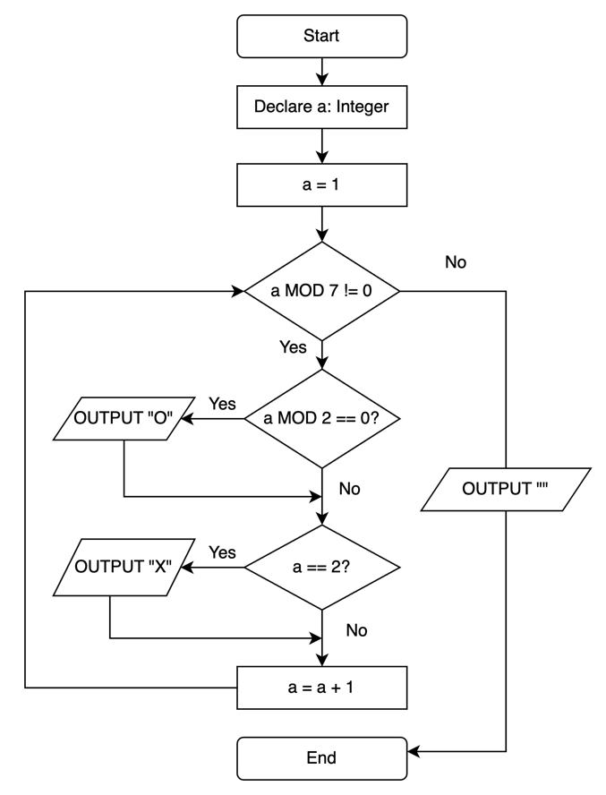

- Write pseudocode for the following Python code:

divisor = 2
for i in range(0, 10, 2):
print(i // divisor)

DECLARE divisor: INTEGER
divisor <- 2
FOR i <- 0 TO 9 STEP 2
OUTPUT (i DIV divisor)

- You are tasked to find the smallest and second smallest integers in an array of integers in a single pass. You are not allowed to sort the array. You can assume that the array has already been initialised with a list of distinct integers.
Express your algorithm using pseudocode.

DECLARE smallest, sec_smallest: INTEGER
// assume the list we get is A
smallest <- INF // INF is an arbitrary large number
sec_smallest <- INF // INF is an arbitrary large number
IF LENGTH(A) < 2 THEN
OUTPUT A
FOR i <- 1 TO LENGTH(A)
IF A[i] < smallest THEN
sec_smallest <- smallest
smallest <- A[i]
END IF
IF A[i] > smallest AND A[i] < sec_smallest THEN
sec_smallest <- A[i]

NEXT i

- 2023/A Level/P1/Q6(c)(ii)
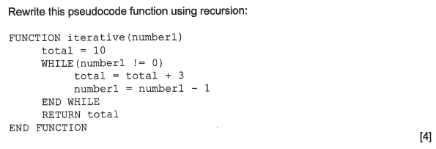
FUNCTION recursive(number1: INTEGER, TOTAL: INTEGER) RETURNS INTEGER
IF number1 == 0 THEN
RETURN TOTAL
ELSE
RETURN recursive(number1-1, TOTAL+3)
END IF
END FUNCTION

CALL recursive(3, 10)

OR
FUNCTION recursive2(number1: INTEGER) RETURNS INTEGER
IF number1 == 0 THEN
RETURN 10
ELSE
RETURN recursive(number1 - 1) + 3
END IF
END FUNCTION

Exercise 13.4 2019/A Level/P1/Q5 H2 Computing (Modified)

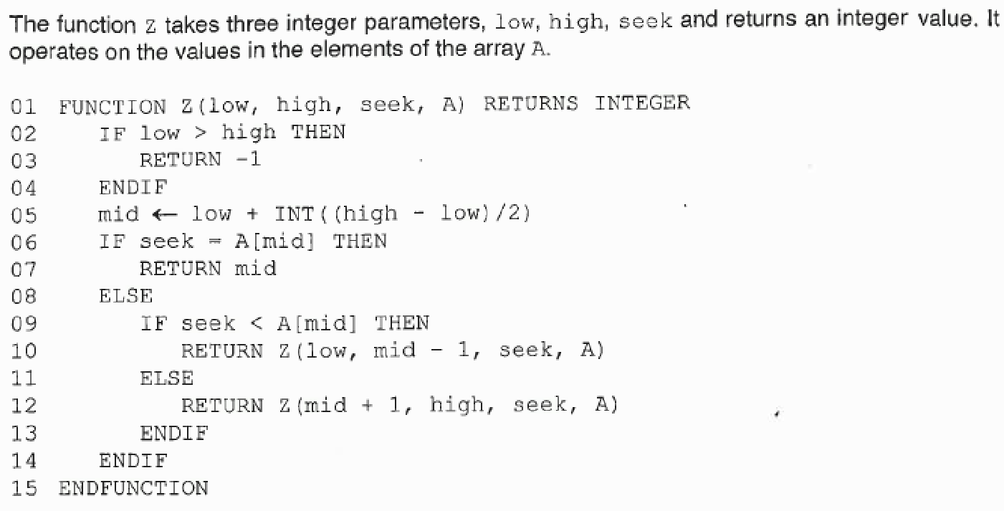
The function is a recursive function
The return statements terminates the recursive calls of the function. They are the base case of the function.

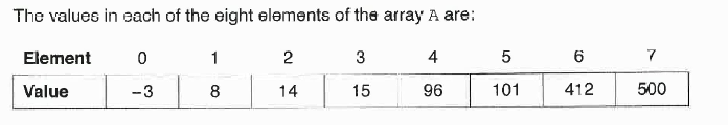

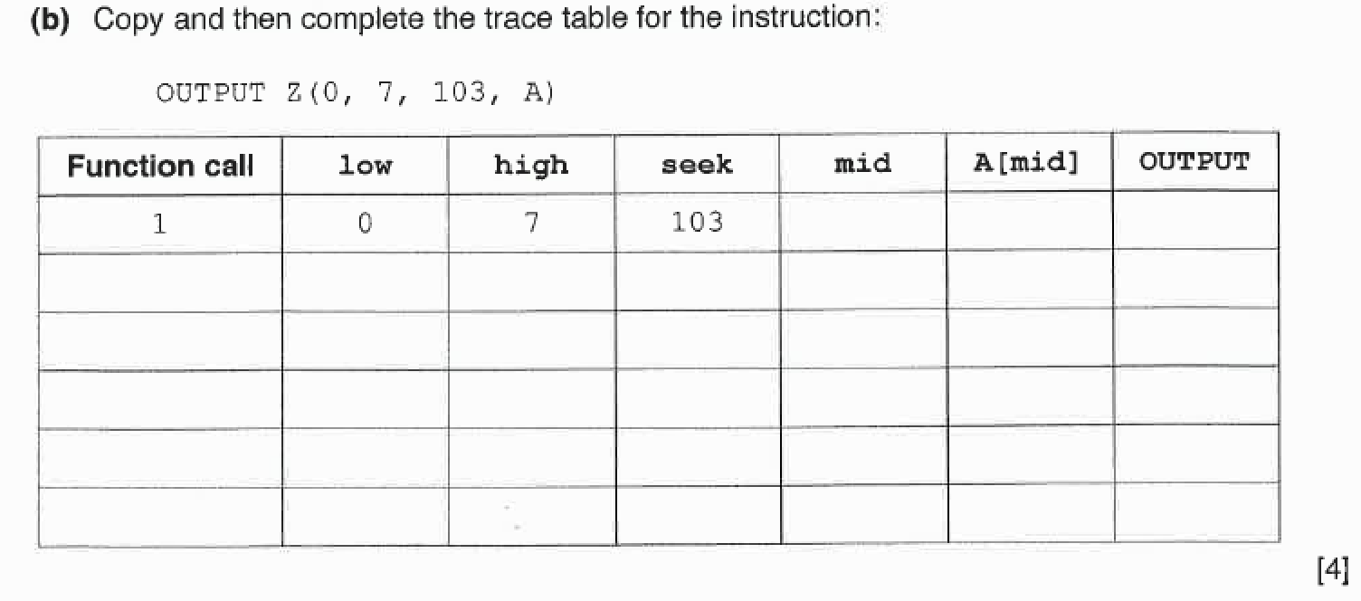
3
15
Z(4, 7, 103, A)
2. 4 7 103 5 101 Z(6, 7, 103, A)
RETURN
3. 6 7 103 6 412 Z(6, 6-1, 103, A)
4. 6 5 103 -1
(low> high)
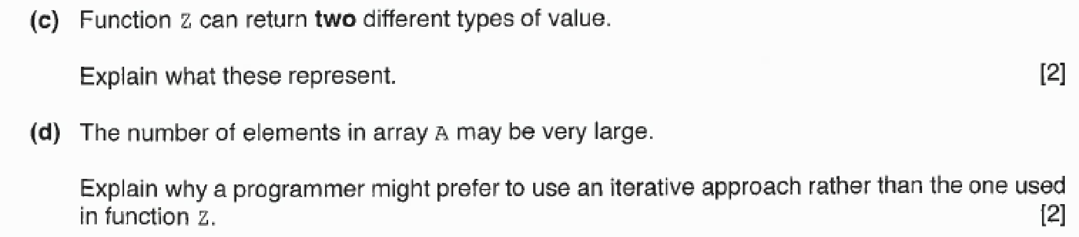

(c) The return value of -1 represents that the seek is not inside the array.
If it returns mid, it returns the index of the seek in the array.

(d) An iterative approach may be preferred because function z may cause a stack overflow and hence cause the memory to run out.

Algorithm Modelling - References

- General Algorithm Design
- Github Notes Chapter 08., Exercise 13
- Cambridge International AS and A Level - Computer Science (9806)
  - Chapter 11

- AQA Computing – AS Computing
  - Unit 1.4

- BBC Bitesize Revision
  - https://www.bbc.com/bitesize/guides/z3bq7ty/revision/1

1. Pseudocode
- Cambridge Pseudocode Guide
  - https://drive.google.com/file/d/1vBm4iswJF66zYW-4oNj1NkRwC1DHbZ3o/view?usp=sharing

2. Flow Charts
- Creately Tutorial on Drawing Flow Charts
  - https://creately.com/blog/diagrams/flowchart-guide-flowchart-tutorial/

- Online Flow Chart Drawing Tool
  - https://www.draw.io/

